ABLE Savings Plan Helps Young Man with Autism Live his Best Life

“John Jr. has always been pretty magical,” says Juli Skeen of her 21-year-old son, the oldest of her four children. “He loves being around people. He makes people happy.”
John Jr. is on the autism spectrum and has developmental disabilities. He also has a passion for sports and classical music, a subtle sense of humor that brings smiles to both friends and strangers, and a strong work ethic as a custodian at a dental group’s administrative office.
John Jr.’s parents, Juli and John Sr., want to make sure their son is prepared with the resources he needs to live his best life—now and into the future. That’s why they signed up for a Washington State ABLE Savings account.
The ABLE Savings Plan is a new way for people living with disabilities to save and invest without risking the loss of their disability benefits. Withdrawals from an ABLE account are tax-free and can be used for big goals—like college, a trip or a vehicle—as well as daily living expenses.
A prepaid card tied to the ABLE account also helps make life a little easier.
“Being able to use the prepaid card through the ABLE account is really convenient,” Juli says.
The card can be loaded with any amount between $10 and $15,000. Account holders can access these funds instantly by using their card online or at cash registers for qualifying expenses, such as housing, transportation, groceries and other daily living costs. They can also track purchases easily online or with an app on a mobile device.
John Sr. says the Washington State ABLE Savings Plan fills the gap between the Social Security funds that John Jr. relies on for his short-term needs, and the trust fund the family set up to support John Jr.’s long-term financial health.
“We feel like the ABLE account fits in the middle, both in terms of being able to save up some resources without affecting his current Social Security funds, in addition to providing a way, whether we’re the guardians or someone else is when we’re gone, to take care of his day-to-day needs,” John Sr. says.
With his ABLE account, John Jr. is more financially secure, independent and prepared to keep living a full, magical life.
“We want to make sure that he is safe and satisfied and taken care of for his lifetime,” John Sr. said.
Watch the Skeen family share their story, here.
Learn more about eligibility and enrollment for a Washington State ABLE Savings Plan at www.WashingtonStateABLE.com or call 1-844-600-2253 / 1-844-888-2253 (TTY).

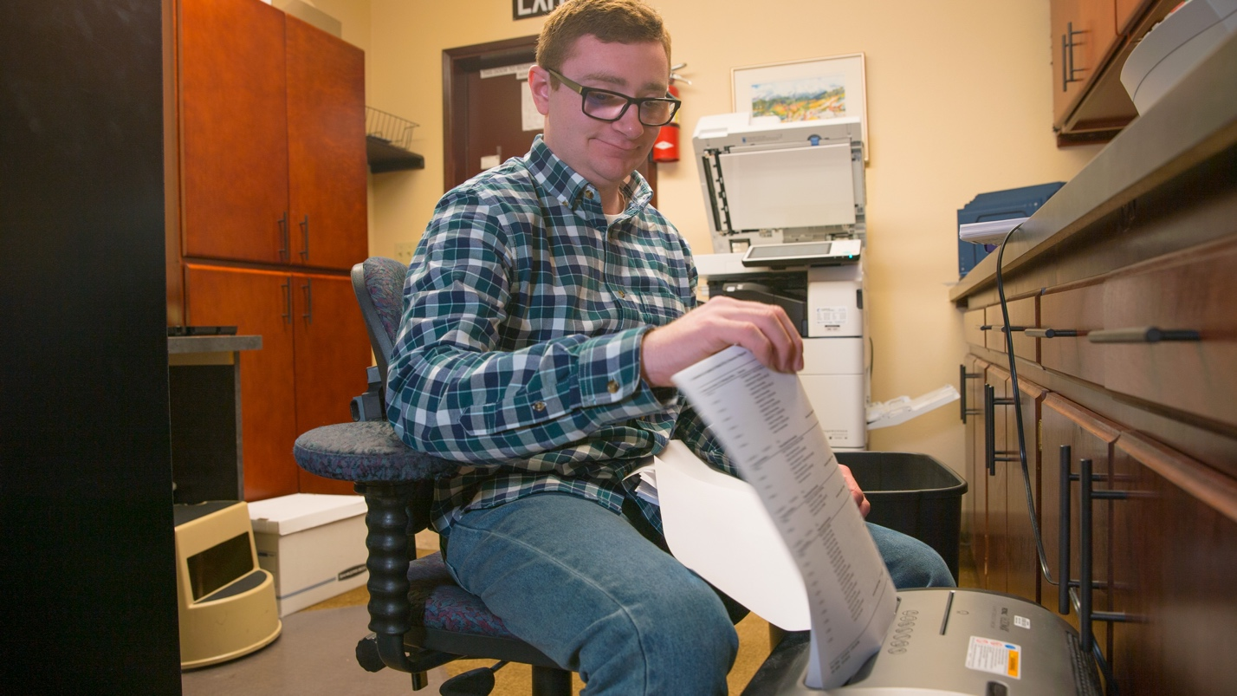
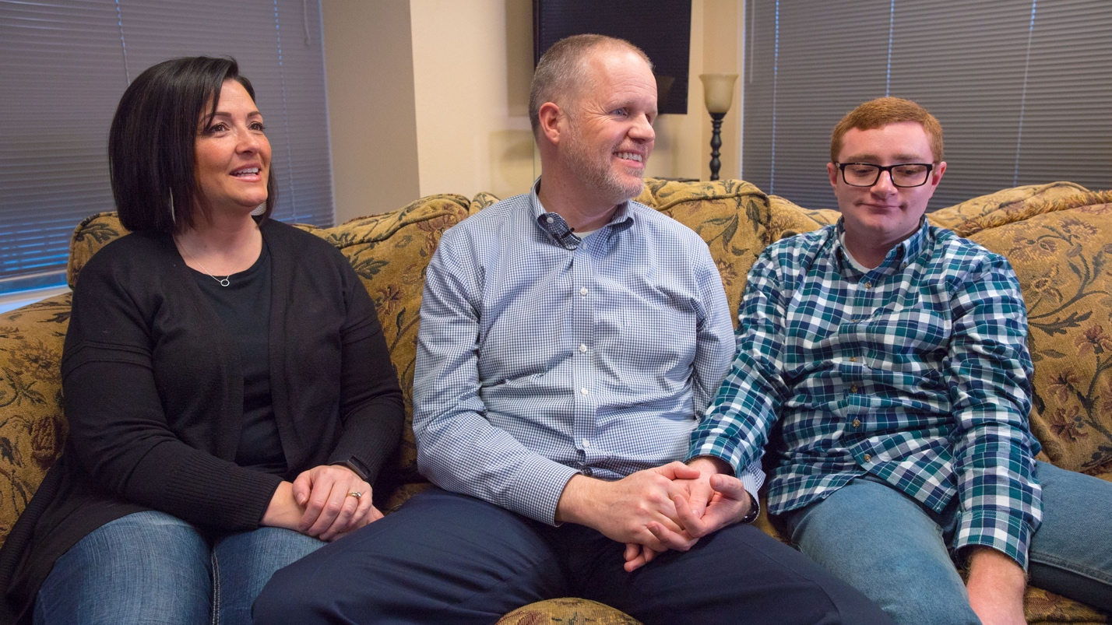
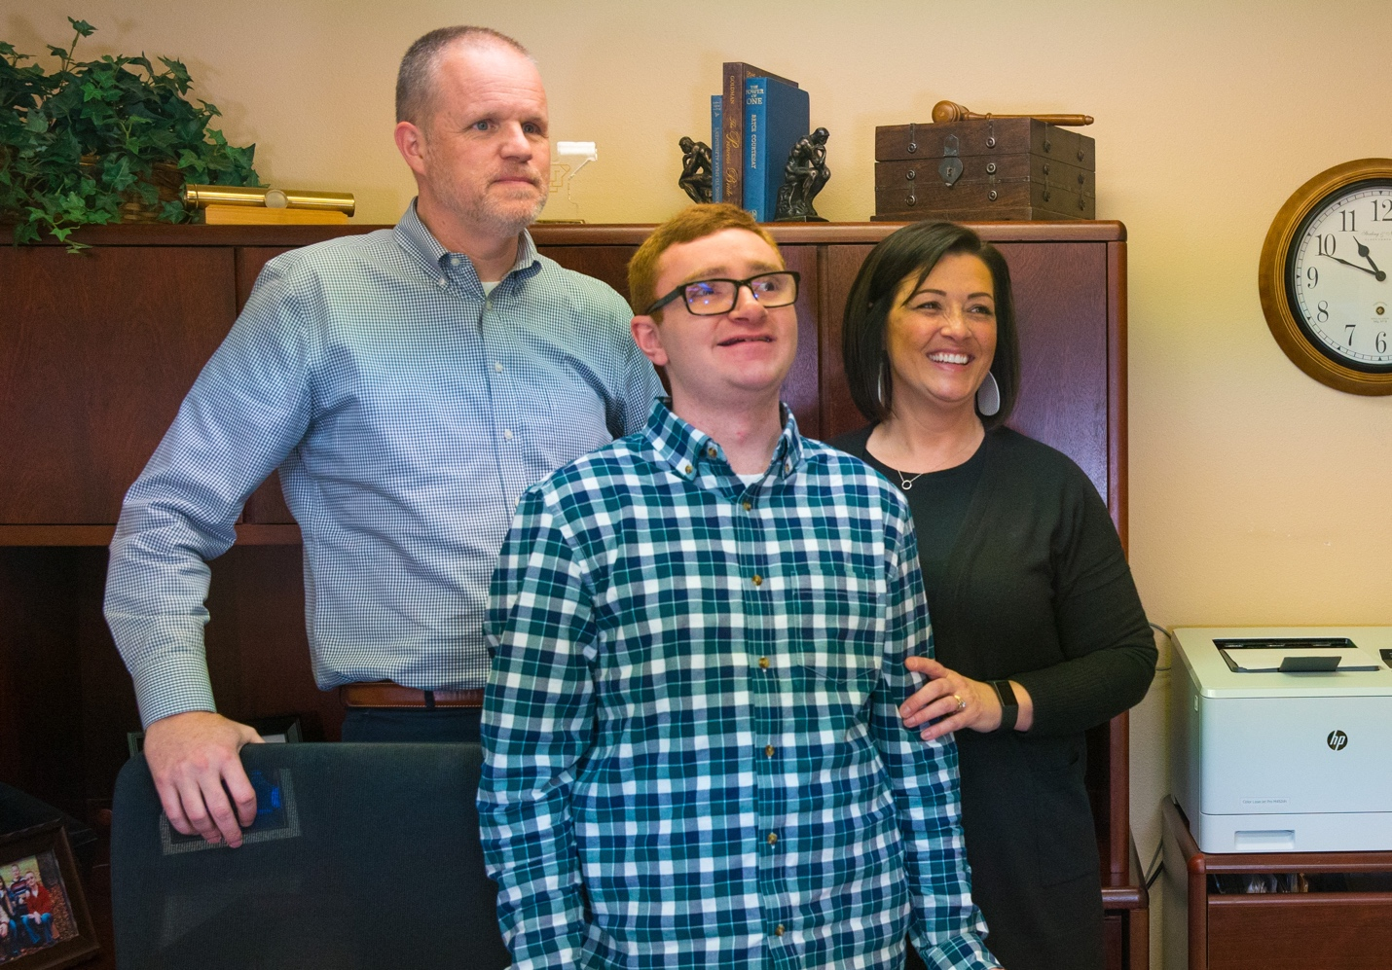
For More information about the washington state able savings plan or to inquire about this story, please contact:
Peter tassoni
360-725-3125
peter.tassoni@commerce.wa.gov

