FAMILIES CAN SAVE FOR DISABLED LOVED ONES WITH AN ABLE ACCOUNT

Just like any parents, Jack and Amy Meikle want the best for their son, Maximus. They want to see him grow up securely and make the most of his life. Now, they’re finding they can pursue that future with the new Washington State Able Savings Plan.

Maximus is autistic and had sensory processing disorder, so Jack and Amy have at times encountered challenges in establishing care and education opportunities for him, as well as finding ways to prepare their son for a fruitful life.

Thankfully, ABLE allows people living with disabilities to have an account in their own name so they can save for future or current-day expenses without risking the loss of benefits they depend on for their daily life. The Meikles were among the first wave of people to help a family member sign up for the plan, which launched last year.

They see their new Washington State ABLE account as an empowering tool for their son’s day-to-day needs, as well as his future.

“I was very excited when Washington was online with ABLE accounts because there are so many things we can’t do for our son, and we have been told ‘no’ so many times in regard to therapy or benefits,” says Jack. “This is something we can do for our son.”

ABLE has been a game-changer for many people with disabilities in Washington, and across the country. There are often significant economic disadvantages for people living with disabilities because there are caps on how much they can save and still receive benefits.

A study by the National Disability Institute found that 25 percent of people with disabilities in the U.S. live in poverty, including those who are receiving benefits. That’s more than double the rate of people without disabilities. The same study also showed that 69 percent of people with disabilities rely on state or federal assistance as their primary source of income, making it very difficult to save money. In addition, federal disability benefits often don’t allow recipients to save more than about $2,000 while maintaining their assistance.

Parents, family members and guardians of people with disabilities are left to navigate these financial situations. Planning for a child or loved one’s financial future was tricky in the past. Again, the rule of thumb for a long time was to not save too much money in the child or dependent’s name.

Now, people living with disabilities can save for long-term goals and be prepared for their future by saving with their ABLE account. Anyone — not just parents or family members — can contribute to an ABLE account, making it an easy and convenient way to save for today or tomorrow.

For parents or guardians, the account can also provide a certain peace of mind.

“Like most parents, we fear for Maximus’s future after our passing. This ABLE account will hopefully be used to ensure he has a good quality of life when we are gone.”

It’s estimated that there are as many as 180,000 Washingtonians eligible for ABLE accounts. If you or someone you know is living with a disability, you can find out more about eligibility for a Washington ABLE Savings Plan at www.WashingtonStateABLE.com or call 1-844-600-2253 / 1-844-888-2253 (TTY).

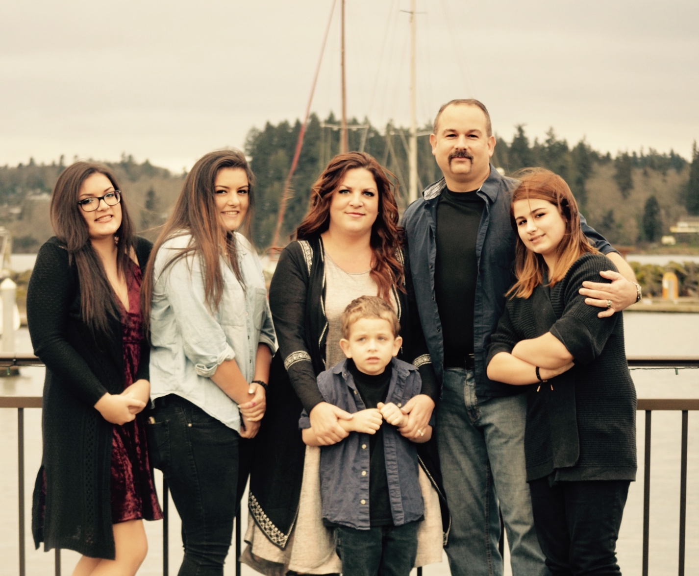

For More information about the washington state able savings plan or to inquire about this story, please contact:
Peter tassoni
360-725-3125
peter.tassoni@commerce.wa.gov

